**Software design Assignment week of 02/05.**

**SCCF/04375P/2021**

1. **Appropriate Software Engineering Methodology.**

An appropriate software engineering methodology for this project is **Agile methodology.**

Agile methodology would be a good fit for the meal planning and grocery shopping application because it emphasizes collaboration, communication, flexibility, and early and frequent delivery of working software.

1. **Context Models.**

The fit context models for this application are:

* Use case diagram.
* Context diagram.

1. Use Case Diagram: A use case diagram is a type of context model that illustrates the different interactions between actors (people, systems, or other entities) and the system itself. In the context of the meal planning and grocery shopping app, the actors could include users, grocery stores, and food delivery services. The use case diagram would illustrate the various ways these actors interact with the app, such as creating a profile, selecting meals for the week, generating a grocery list, ordering groceries, and tracking nutritional information.

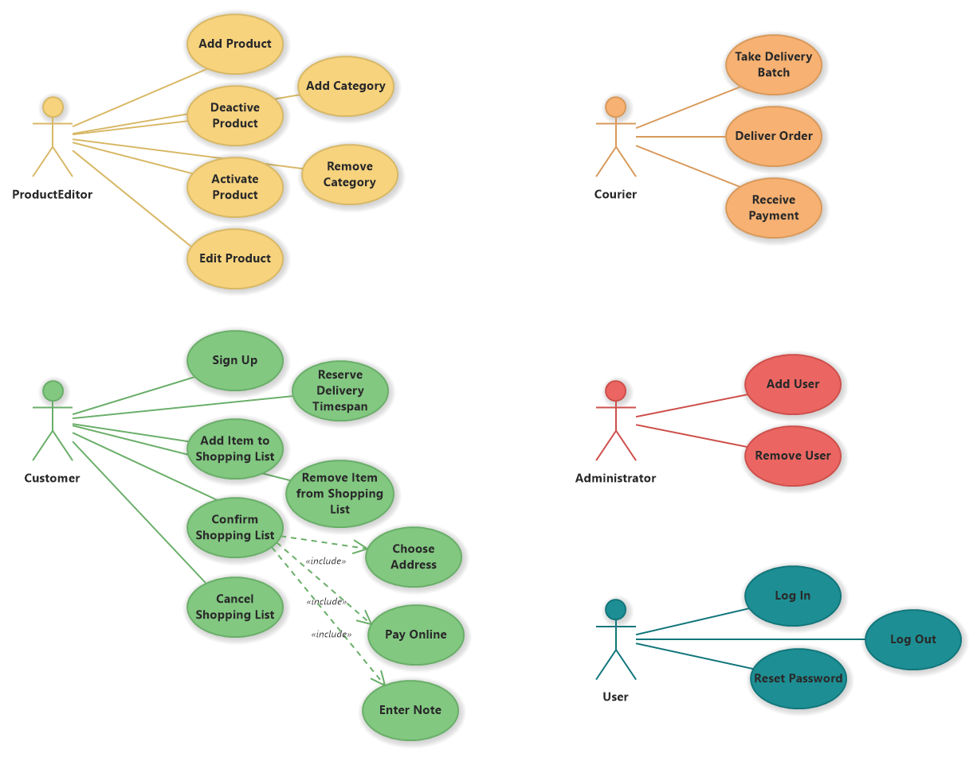

1. Context Diagram: A context diagram is a type of context model that illustrates the system in relation to its external environment. The context diagram would show the meal planning and grocery shopping app as the main system, with other entities such as grocery stores, food delivery services, and the user's device as external entities. The diagram would show the different inputs and outputs of the system, such as the user inputting their dietary preferences, the app generating personalized meal suggestions, and the app providing information on grocery deals and discounts.

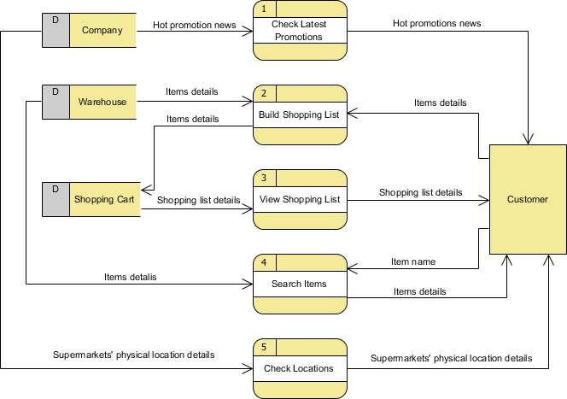

1. **Interaction Models.**

The fit interaction models that could be used for the project are:

* Sequence Diagram
* Activity Diagram
* State Machine Diagram

1. Sequence Diagram: A sequence diagram is a type of interaction model that shows the interactions between objects or components over time. In the context of the meal planning and grocery shopping app, a sequence diagram could show the steps involved in generating a personalized meal plan for the user, from the user inputting their dietary preferences to the app generating a list of suggested meals based on those preferences.

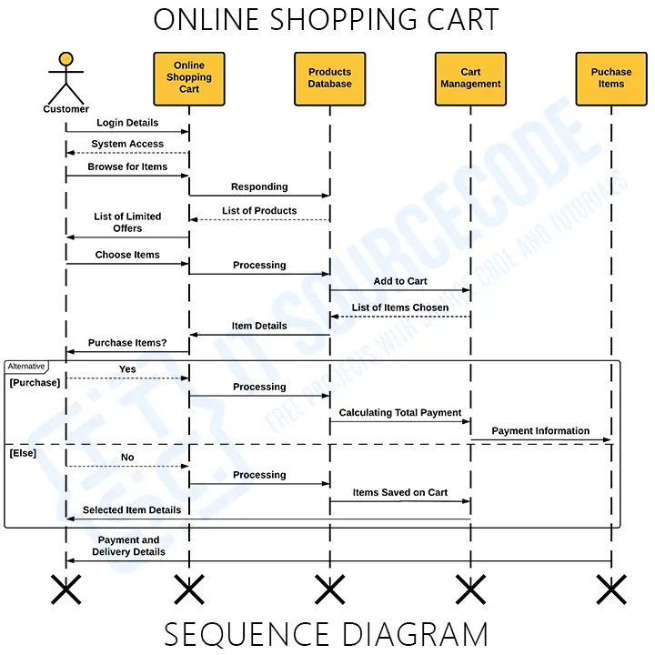

1. Activity Diagram: An activity diagram is a type of interaction model that shows the workflow or process involved in completing a specific task or activity. In the context of the meal planning and grocery shopping app, an activity diagram could show the steps involved in creating a grocery list, from selecting meals for the week to identifying the necessary ingredients and generating the list.

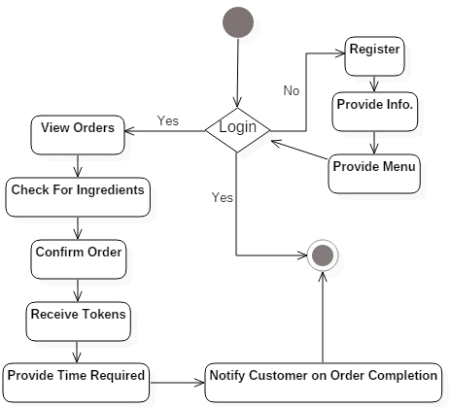

1. State Machine Diagram: A state machine diagram is a type of interaction model that shows the different states and transitions of an object or system. In the context of the meal planning and grocery shopping app, a state machine diagram could show the different states of an order for groceries, from being placed to being delivered or picked up by the user.

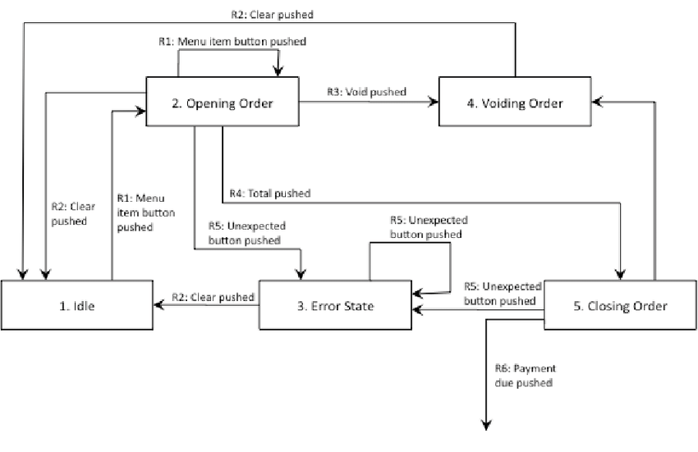

1. **Structural Model**

The structural model for the meal planning and grocery shopping app would involve several components that work together to provide the functionality of the app. Here are a few common components that could be included in the structural model:

1. User Interface: The user interface is the part of the app that users interact with directly. This could include screens for creating a profile, selecting meals, generating grocery lists, and tracking nutritional information. The user interface should be designed to be intuitive and user-friendly, with clear and concise instructions.

2. Database: The database is the part of the app that stores user information, meal suggestions, grocery lists, and other data. The database should be designed to be secure and scalable, with appropriate backups and redundancy to ensure data integrity.

3. Meal Planning Algorithm: The meal planning algorithm is the part of the app that generates personalized meal suggestions based on the user's dietary preferences and other factors such as allergies or food restrictions. The algorithm should be designed to be accurate and efficient, taking into account factors such as nutrient balance, taste preferences, and meal variety.

4. Grocery Integration: The grocery integration component allows users to order groceries directly through the app from grocery stores or food delivery services. This component should be designed to be secure and reliable, with appropriate safeguards in place to protect user data and financial information.

5. Analytics and Reporting: The analytics and reporting component provides insights into user behavior and app usage. This component should be designed to be flexible and customizable, allowing for the generation of reports and visualizations that are tailored to the needs of different stakeholders such as users, grocery stores, and food delivery services.

1. **Behavioral Models**

Behavioral models describe the dynamic behavior of a system, and can be used to show how the various components of the meal planning and grocery shopping app interact with each other and with users. Here are three common behavioral models that could be used for this app:

1. Use Case Scenarios: Use case scenarios are narratives that describe how users interact with the app in different situations. These scenarios could describe how a user creates a profile, selects meals for the week, generates a grocery list, and orders groceries through the app. Use case scenarios can help identify potential issues or challenges that users may encounter, and can be used to refine the app's functionality and user experience.

2. Sequence Diagrams: Sequence diagrams show the interactions between objects or components over time. In the context of the meal planning and grocery shopping app, a sequence diagram could show how a user selects meals for the week and generates a grocery list, and how this information is communicated to grocery stores or food delivery services for order fulfillment. Sequence diagrams can help identify potential issues or bottlenecks in the system, and can be used for testing and debugging the app during development.

3. State Machine Diagrams: State machine diagrams show the different states and transitions of an object or system. In the context of the meal planning and grocery shopping app, a state machine diagram could show the different states of an order for groceries, from being placed to being fulfilled and delivered or picked up by the user. State machine diagrams can help identify potential issues or areas for improvement in the app's order fulfillment process, and can be used to optimize the app's functionality and efficiency.